1.What is java ?
Ans: Java is a high-level, object-oriented programming language and platform designed for building a wide range of applications, including:
1. Android apps 2. Web applications 3. Enterprise software 4. Desktop applications 5. Games
6. IoT (Internet of Things) devices
2. What are the features of Java?
Ans: 1. Platform Independence 2. Object-Oriented 3. Simple and Familiar 4. Robust 5. Secure 6. Multithreaded 7. High Performance 8. Distributed Computing 9. Dynamic and Extensible 10. Portable 11. Garbage Collection 12. Rich Standard Library 13. Scalable
3. What is the Difference between JDK and JRE?
- The Java Runtime Environment (JRE) is basically the Java Virtual Machine (JVM) where Java programs are being executed. It also includes browser plugins for applet execution.
- The Java Development Kit (JDK) is the full-featured Software Development Kit for Java, including the JRE, the compilers, and tools (like JavaDoc, and Java Debugger), in order for a user to develop, compile and execute Java applications.
4. What are packages ? Mention the types of packages
Ans: In Java, a package is a namespace that organizes classes and interfaces into a logical group. It is used to avoid name conflicts and to manage large codebases efficiently by grouping related classes together.
Types of packages:
- Built-in Packages: Some built-in packages java.lang, java.util, java.io, java.net, java.sql
- User-Defined Packages: Example
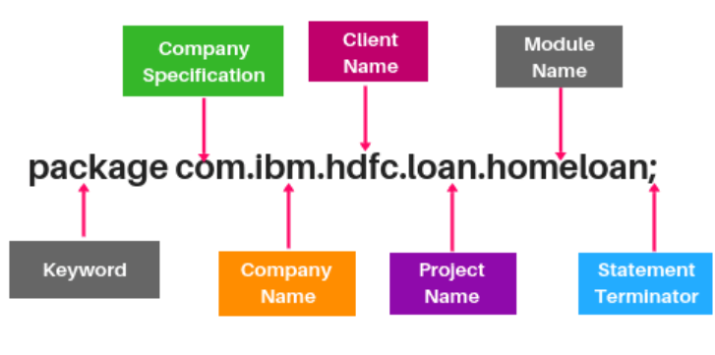
5. Mention different types of access modifiers
Ans: Public: Accessible everywhere.
Private: Accessible only within the class.
Protected: Accessible within the package and by subclasses in other packages.
Default: Accessible only within the same package.
6. Mention different types of datatypes
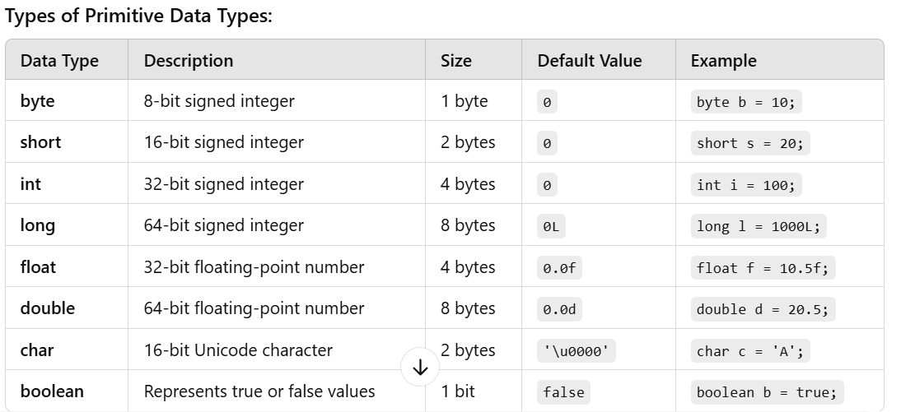
7. What is scanner class?
Ans: In Java, Scanner is a class in java.util package used for obtaining the input of the primitive types like int, double, etc. and strings.
8. Mention types of operators
Ans: 1. Arithmetic Operators: Used for performing basic mathematical operations. Example: +,-,*,/,%
2. Relational (Comparison) Operators Used for comparing two values.
Example: ==,!=,<,>,<=,>=.
3. Logical Operators: Used for performing logical operations on boolean values.
Example: &&,!
4. Bitwise Operators: Operate on bits and perform bit-by-bit operations.
Example: &,^,~,<<,>>,>>>.
5. Assignment Operators: Used to assign values to variables.
Example: =,+=,-=,*=,/=,%=.
6. Unary Operators: Operate on a single operand.
Example: +,-,++,--,!
7. Ternary Operator: A shorthand for if-else statements.
Example: ?:
8. instanceof Operator: Used to test whether an object is an instance of a specific class or subclass. Example: instanceof

9. What is a Constructor in Java?
Ans: A constructor is a special method in Java used to initialize objects. It is automatically called when an object of a class is created. Constructors have the same name as the class and do not have a return type (not even void).
Types of Constructors in Java
1. Default Constructor (No-Argument Constructor)
- A constructor with no parameters.
- It initializes default values for the object's attributes.
2. Parameterized Constructor
- A constructor that accepts parameters to initialize an object with specific values.
3. Copy Constructor
- A constructor that creates a new object as a copy of an existing object.
- Java does not provide a built-in copy constructor, but it can be implemented manually.
4. Constructor Overloading
- Multiple constructors with the same name but different parameter lists.
- Allows creating objects in different ways.
5. Chaining Constructors: A constructor can call another constructor of the same class using the this() keyword.
6. Super Constructors: A constructor can call the parent class's constructor using the super() keyword.

10. What are Variables in Java
Ans: Variables are containers for storing data values. They are assigned a type and can hold values of that type.
Types of Variables
- Instance Variables (Non-Static Variables):
  - Declared inside a class but outside any method, constructor, or block.
- Static Variables (Class Variables):
- A static variable is associated with a class rather than an instance. Static variables are shared across all instances of a class.There is only one copy of a static variable per class. Non-static variables cannot be called inside static methods.
- Static variables in Java are memory-efficient as they are not duplicated for each instance.
- Local Variables:
- Declared inside a method, constructor, or block.
- Accessible only within the block where they are defined.
- Must be initialized before use.
- Final Variables:
- Declared using the final keyword.
- Cannot be reassigned once initialized (constant).

11. What are methods in java?
Ans: Methods are blocks of code designed to perform specific tasks. They are invoked to execute their functionality.
Types of Methods
- Instance Methods:
  - Belong to an instance (object) of a class.
  - Require an object to be called.
- Static Methods:
- Declared with the static keyword.
- Belong to the class, not a specific object.
- Can be called without creating an object.
- Abstract Methods:
- Declared without a body, using the abstract keyword.
- Must be implemented by subclasses.
- Final Methods:
- Declared using the final keyword.
- Cannot be overridden by subclasses.
- Synchronized Methods:
- Used in multithreading to restrict access to a method to one thread at a time.
12. Difference between static and non-static members?
Ans: 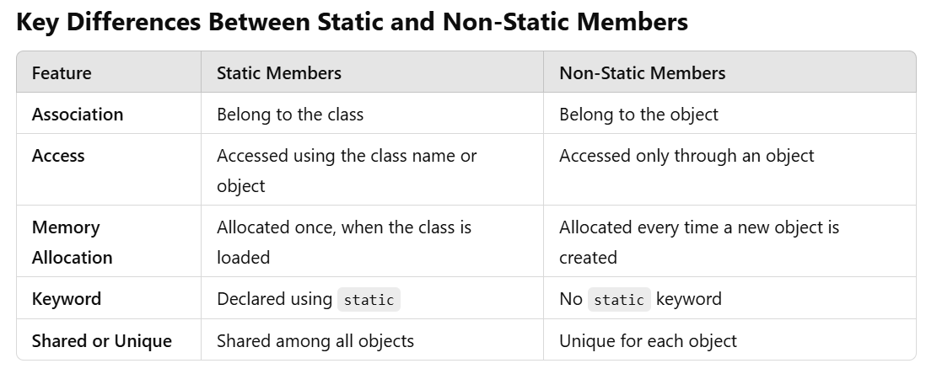
13. What is Final and super keyword in java?
Ans: The final keyword is used to restrict modification. It can be applied to variables, methods, and classes.
Final Variables
- A final variable becomes a constant, and its value cannot be changed once initialized.
Final Methods
- A final method cannot be overridden by subclasses, ensuring its behavior remains unchanged in derived classes.
Final Classes
- A final class cannot be extended or inherited by any other class.
Super Keyword
The super keyword is used to refer to the immediate parent class of a subclass. It is commonly used for:
- Calling the parent class's constructor.
- Accessing the parent class's methods.
- Accessing the parent class's variables.
14. Demonstrate oop’s concepts?
Ans: 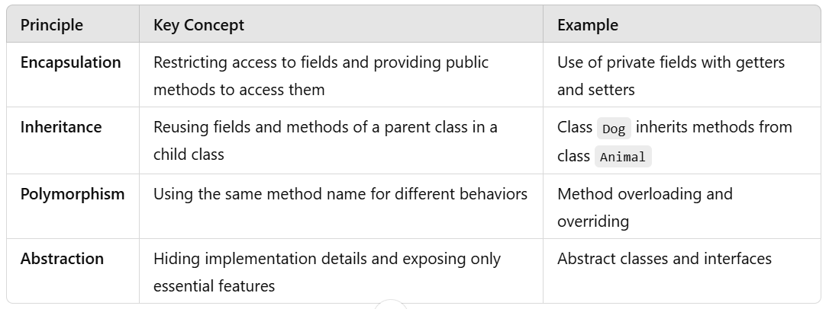

Example program for Encapsulation:
class Student {
private String name; // Encapsulated field
private int age;

// Constructor
public Student(String name, int age) {
this.name = name;
this.age = age;
}

// Getter for name
public String getName() {
return name;
}

// Setter for name
public void setName(String name) {
this.name = name;
}

// Getter for age
public int getAge() {
return age;
}

// Setter for age
public void setAge(int age) {
if (age > 0) {
this.age = age;
} else {
System.out.println("Age must be positive.");
}
}
}

public class Main {
public static void main(String[] args) {
Student student = new Student("Alice", 20);
System.out.println("Name: " + student.getName());
System.out.println("Age: " + student.getAge());

student.setAge(25); // Update age using setter
System.out.println("Updated Age: " + student.getAge());
}
}

Example program for Inheritance:
class Animal {
void eat() {
System.out.println("This animal eats food.");
}
}

class Dog extends Animal {
void bark() {
System.out.println("The dog barks.");
}
}

public class Main {
public static void main(String[] args) {
Dog dog = new Dog();
dog.eat(); // Inherited from Animal
dog.bark();
}
}

Example program for Polymorphism:
1. Method Overloading (Compile-Time Polymorphism)
class Calculator {
int add(int a, int b) {
return a + b;
}

double add(double a, double b) {
return a + b;
}
}

public class Main {
public static void main(String[] args) {
Calculator calc = new Calculator();
System.out.println("Sum of integers: " + calc.add(5, 10));
System.out.println("Sum of doubles: " + calc.add(5.5, 10.5));
}
}

2.Method Overriding (Runtime Polymorphism)

class Animal {
void sound() {
System.out.println("This animal makes a sound.");
}
}

class Cat extends Animal {
@Override
void sound() {
System.out.println("The cat meows.");
}
}

public class Main {
public static void main(String[] args) {
Animal animal = new Cat(); // Runtime polymorphism
animal.sound(); // Calls the overridden method in Cat
}
}

Example for Abstract class:
abstract class Shape {
abstract void draw(); // Abstract method

void display() { // Concrete method
System.out.println("This is a shape.");
}
}

class Circle extends Shape {
@Override
void draw() {
System.out.println("Drawing a circle.");
}
}

public class Main {
public static void main(String[] args) {
Shape shape = new Circle();
shape.display();
shape.draw();
}
}

Example for Interface:
interface Animal {
void sound(); // Abstract method
}

class Dog implements Animal {
@Override
public void sound() {
System.out.println("The dog barks.");
}
}

public class Main {
public static void main(String[] args) {
Animal animal = new Dog();
animal.sound();
}
}

15. How to achieve the multiple inheritance in java?
Ans: Java does not support multiple inheritance through classes to avoid the Diamond Problem (ambiguity caused by inheriting from multiple classes with methods of the same name). However, multiple inheritance is achieved in Java through interfaces.
By using interfaces and overriding methods explicitly, Java effectively enables multiple inheritance without the pitfalls.

16. What Are Arrays in Java?
Ans: An array is a data structure in Java used to store multiple values of the same type in a single variable. Arrays are fixed in size, meaning the length is determined at the time of creation and cannot be changed later.
Key Features of Arrays
- Fixed Size: The size of an array is defined during its declaration and remains constant.
- Homogeneous Elements: Arrays store elements of the same data type.
- Indexed: Array elements are accessed using an index, which starts at 0.
- Contiguous Memory: Arrays are stored in contiguous memory locations.

17. Types of Arrays in Java
Ans: 1. One-Dimensional Arrays
A one-dimensional array is a list of elements of the same type stored in a single row.
Syntax: dataType[] arrayName = new dataType[size];
public class Main {
public static void main(String[] args) {
int[] numbers = new int[5]; // Declaration and instantiation
numbers[0] = 10; // Initialization
numbers[1] = 20;
numbers[2] = 30;

// Accessing array elements
for (int i = 0; i < numbers.length; i++) {
System.out.println("Element at index " + i + ": " + numbers[i]);
}
}
}

2. Multi-Dimensional Arrays
Multi-dimensional arrays store data in a grid-like structure (e.g., a table or matrix). They are arrays of arrays.
2.1 Two-Dimensional Arrays
A two-dimensional array is a table with rows and columns.
Syntax: dataType[][] arrayName = new dataType[rows][columns];

public class Main {
public static void main(String[] args) {
int[][] matrix = {
{1, 2, 3},
{4, 5, 6},
{7, 8, 9}
};

// Accessing elements
for (int i = 0; i < matrix.length; i++) {
for (int j = 0; j < matrix[i].length; j++) {
System.out.print(matrix[i][j] + " ");
}
System.out.println();
}
}
}

3. Jagged Arrays
A jagged array is an array of arrays where the inner arrays can have different lengths.
Syntax: dataType[][] arrayName = new dataType[rows][];

public class Main {
public static void main(String[] args) {
int[][] jaggedArray = new int[3][];
jaggedArray[0] = new int[]{1, 2};
jaggedArray[1] = new int[]{3, 4, 5};
jaggedArray[2] = new int[]{6};

// Accessing elements
for (int i = 0; i < jaggedArray.length; i++) {
for (int j = 0; j < jaggedArray[i].length; j++) {
System.out.print(jaggedArray[i][j] + " ");
}
System.out.println();
}
}
}

18. what is the difference between String ,string buffer and string builder?
Ans: 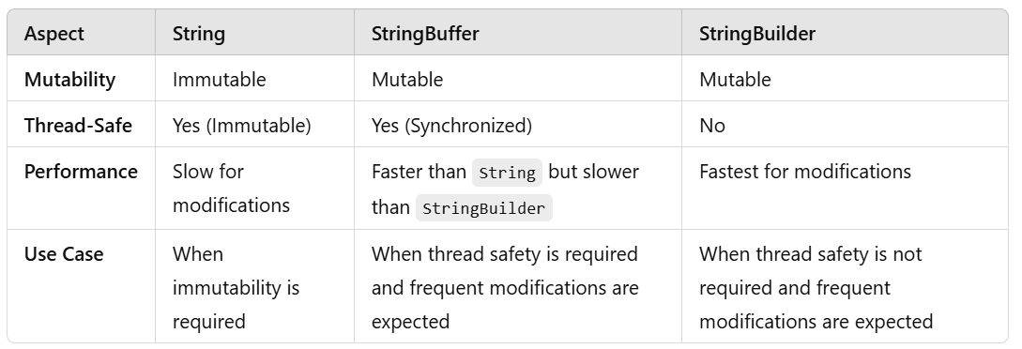

19. What is multithreading in java?
Ans: Multithreading in Java allows the simultaneous execution of two or more threads to maximize the utilization of CPU. Each thread runs independently, sharing the same memory space, making Java programs efficient and responsive.

- Thread: A lightweight subprocess, the smallest unit of processing in a program.
- Multithreading: The process of executing multiple threads simultaneously.
- Concurrency: Running multiple threads in an overlapping time frame (not necessarily parallel, depends on the CPU's capability).

Creating Threads in Java
- There are two main ways to create a thread in Java:
1. Extending the Thread Class
- By extending the Thread class, you override the run() method with the code you want the thread to execute.

class MyThread extends Thread {
@Override
public void run() {
for (int i = 1; i <= 5; i++) {
System.out.println(Thread.currentThread().getName() + ": " + i);
}
}
}

public class Main {
public static void main(String[] args) {
MyThread thread1 = new MyThread();
MyThread thread2 = new MyThread();

thread1.start(); // Starts thread1
thread2.start(); // Starts thread2
}
}

2. Implementing the Runnable Interface
This method is preferred when your class needs to extend another class (as Java doesn’t support multiple inheritance).
class MyRunnable implements Runnable {
@Override
public void run() {
for (int i = 1; i <= 5; i++) {
System.out.println(Thread.currentThread().getName() + ": " + i);
}
}
}

public class Main {
public static void main(String[] args) {
Thread thread1 = new Thread(new MyRunnable());
Thread thread2 = new Thread(new MyRunnable());

thread1.start(); // Starts thread1
thread2.start(); // Starts thread2
}
}

20. Explain Thread Lifecycle methods
Ans: A thread in Java goes through the following stages:
- New: The thread is created but not started yet (Thread thread = new Thread()).
- Runnable: The thread is ready to run and waiting for the CPU (thread.start()).
- Running: The thread is executing its task.
- Blocked/Waiting: The thread is waiting for resources or another thread to complete.
- Terminated: The thread has completed its task (run() method execution ends).
21. Explain Thread Class Methods
Ans: Here are some important methods of the Thread class:
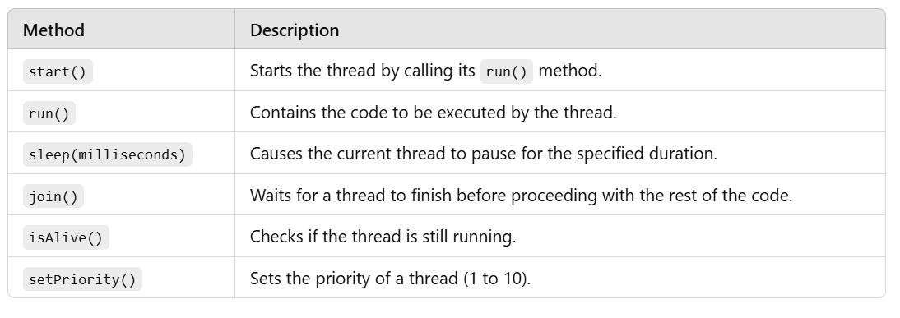
22. What is Synchronization in Multithreading?
Ans: When multiple threads access shared resources, synchronization is used to prevent thread interference and maintain consistency.
class Counter {
private int count = 0;

public synchronized void increment() { // Synchronized method
count++;
}

public int getCount() {
return count;
}
}

class MyThread extends Thread {
Counter counter;

MyThread(Counter counter) {
this.counter = counter;
}

@Override
public void run() {
for (int i = 0; i < 1000; i++) {
counter.increment();
}
}
}

public class Main {
public static void main(String[] args) throws InterruptedException {
Counter counter = new Counter();
MyThread thread1 = new MyThread(counter);
MyThread thread2 = new MyThread(counter);

thread1.start();
thread2.start();

thread1.join();
thread2.join();

System.out.println("Final Count: " + counter.getCount()); // Consistent result
}
}

23.What is Exception Handling in Java?
Ans: It is a mechanism to handle runtime errors, ensuring the normal flow of the application. It is used to detect, handle, and recover from errors gracefully without crashing the program.
Exception Handling Keywords
Java provides the following keywords for exception handling:
- try: Contains the code that might throw an exception.
- catch: Used to handle the exception.
- finally: Contains the cleanup code, executed regardless of exception occurrence.
- throw: Used to explicitly throw an exception.
- throws: Declares exceptions that a method can throw.

24. What is Exception?
Ans: An exception is an event that disrupts the normal flow of a program. It occurs during the execution of a program and can be caused by:
- Invalid user input (e.g., dividing by zero).
- File not found or inaccessible.
- Network connection issues.
- Accessing an array out of bounds.
• Checked Exceptions (e.g., IOException, SQLException): Handled at compile time.
• Unchecked Exceptions (e.g., ArithmeticException, NullPointerException): Occur at runtime.
25. What is Collections in Java?
Ans: In Java, collections are part of the Java Collections Framework (JCF), which provides a standardized way to work with groups of objects. These collections allow you to store, retrieve, manipulate, and communicate aggregate data effectively.
Collection Types
Collection: The root interface for most collections.
1. List
- Maintains order.
- Allows duplicates.
- Examples: ArrayList, LinkedList.
2. Set
- No duplicates.
- Order may or may not be maintained, depending on the implementation.
- Examples: HashSet, TreeSet.
3. Queue
- Follows FIFO.
- Examples: LinkedList, PriorityQueue.
4. Deque
- Double-ended queues allow addition or removal from both ends.
- Examples: ArrayDeque.
5. Map
- Key-value pairs.
- No duplicate keys; values can be duplicated.
- Examples: HashMap, TreeMap.

26. What is wrapper class ?
Ans: In Java, wrapper classes are used to convert primitive data types (e.g., int, char, double) into corresponding objects. These classes are part of the java.lang package and provide a way to use primitives as objects when needed, such as when working with collections or using Java's object-oriented features.
Key Points
- Wrapper classes enable the use of primitives in an object-oriented way.
- They are immutable and provide several utility methods.
- Autoboxing and unboxing simplify the conversion between primitives and wrapper objects.
- Useful in situations where objects are required (e.g., collections, generics).
By using wrapper classes effectively, Java developers can handle primitives and objects seamlessly in their code.

27. What are Generics in Java?
Ans: Generics in Java allow developers to define classes, interfaces, and methods with type parameters. This provides a way to ensure type safety and reusability while working with objects in Java, especially when dealing with collections.
Generic Syntax
- Class Declaration: class ClassName<T> { ... }
- Method Declaration: <T> ReturnType methodName(T param) { ... }
class Box<T> {
private T item;

public void setItem(T item) {
this.item = item;
}

public T getItem() {
return item;
}
}

public class Main {
public static void main(String[] args) {
Box<String> stringBox = new Box<>();
stringBox.setItem("Hello");
System.out.println(stringBox.getItem()); // Output: Hello

Box<Integer> intBox = new Box<>();
intBox.setItem(123);
System.out.println(intBox.getItem()); // Output: 123
}
}

28. What are Wildcards in Generics?
- Unbounded Wildcard (?): Represents an unknown type.
Example:
public void printList(List<?> list) {
for (Object obj : list) {
System.out.println(obj);
}
}

Upper-Bounded Wildcard (? extends Type): Accepts Type or its subclasses.
Example: public void processNumbers(List<? extends Number> list) {
for (Number num : list) {
System.out.println(num);
}
}
Lower-Bounded Wildcard (? super Type): Accepts Type or its superclasses.
Example: public void addNumbers(List<? super Integer> list) {
list.add(10);
list.add(20);
}

29. What are features of Java8?
Ans: Java 8 features focuses on functional programming, improved performance, and ease of use. Below is an overview of the key features introduced in Java 8:
1. Lambda Expressions
- Enable functional programming by allowing you to write concise, anonymous methods.
- Syntax: (parameters) -> expression
(parameters) -> { statements }
- Example:
List<String> names = Arrays.asList("John", "Jane", "Joe");
names.forEach(name -> System.out.println(name));

2. Functional Interfaces
- Interfaces with a single abstract method (SAM) that can be implemented using lambda expressions.
- Common functional interfaces in java.util.function:
  - Predicate<T>: Tests a condition on an object.
  - Function<T, R>: Transforms an object of type T into type R.
  - Consumer<T>: Performs an action on an object of type T.
  - Supplier<T>: Supplies an object of type T.
- Example: Predicate<Integer> isEven = n -> n % 2 == 0;
System.out.println(isEven.test(4)); // true

3. Stream API
- Provides a functional approach to process collections and other data sources.
- Supports operations like filter, map, reduce, sorted, collect, etc.
- Example: List<Integer> numbers = Arrays.asList(1, 2, 3, 4, 5);
List<Integer> evenNumbers = numbers.stream()
.filter(n -> n % 2 == 0)
.collect(Collectors.toList());
System.out.println(evenNumbers); // [2, 4]

4. Default Methods in Interfaces
- Allows interfaces to have methods with a default implementation.
- Enables backward compatibility without breaking existing code.
- Example:
interface Vehicle {
default void start() {
System.out.println("Vehicle is starting...");
}
}
class Car implements Vehicle { }
public class Main {
public static void main(String[] args) {
Car car = new Car();
car.start(); // Vehicle is starting...
}
}
5.Date and Time API (java.time)
Introduced new classes for date and time manipulation, replacing the old java.util.Date and Calendar.
Key classes:
- LocalDate, LocalTime, and LocalDateTime: Immutable representations of date and time.
- Instant: Represents a timestamp.
- Duration and Period: Represent time differences.
- DateTimeFormatter: Formats dates and times.
Example:
LocalDate today = LocalDate.now();
System.out.println(today); // e.g., 2025-01-17

LocalDate birthday = LocalDate.of(2000, Month.JANUARY, 1);
Period age = Period.between(birthday, today);
System.out.println("Age: " + age.getYears()); // Age: 25
6.Method References
A shorthand for referring to methods of existing classes or objects.
Syntax: ClassName::methodName or instance::methodName.
Example:
List<String> names = Arrays.asList("John", "Jane", "Joe");
names.forEach(System.out::println); // Method reference

